**Name: Mayank Ramji Ravariya**

**UID: 2022600049**

**Branch: AIML**

**All India Criminal Record**

**Scenario:**

The Indian Crime Investigation Department wants to maintain a record of all criminals, both National and International. This should have all the details of the criminals which will be useful for identifying suspects.

# Entities:

1. Criminal (strong entity)
2. Physical Appearance (weak entity)
3. Crime (weak entity)
4. Current Crime Record (strong entity)
5. Previous Crime Record (strong entity)
6. Family (weak entity)

# Attributes:

1. Criminal (criminal_id, name, birth_place, dob, age, gender, blood_group, nationality, threat_level, previous_occupation, current_occupation)

Simple Attribute: **name, dob, birth_place, blood_group**

Composite Attribute: nationality (national_id, passport_id), previous_occupation (name, income), current_occupation(name, income)

Single Valued: **criminal_id**

Derived: **age**

1. Physical Appearances (height, weight, eye_color, hair, scars_and_marks)

Simple Attribute: **height, weight, eye_color, hair**

Multivalued: scars_and_marks

1. Family (parents, consort, siblings, children)

Composite Attribute: parents (mother (name, occupation), father(name, occupation)),

consort (name, occupation), siblings (name), children (name)

1. Current Crime (crime_id, type_of_crime, victims, crime_scene, date, arrest_details, sentence)

Simple Attributes: **type_of_crime**

Composite Attribute: crime_scene (location, date), arrest_details (location, date, arrestor), sentence (type, sentence_date, period, release_date, fine)

Single valued: **crime_id**

Multivalued: victims

5) Previous Crime (crime_id, type_of_crime, victims, crime_scene, date, arrest_details, sentence)

Simple Attributes: **type_of_crime**

Composite Attribute: crime_scene (location, date), arrest_details (location, date, arrestor),sentence (type, sentence_date, period, release_date, fine)

Single valued: **crime_id**

Multivalued: victims

6) Crime (arms_possession, jail)

Simple Attributes: **arms_possession**

Composite Attribute: jail (prison (location), police_station (fir_id))

**Relationships:**

1. Criminal has an Appearance.
2. Criminal has Family.
3. Family Record includes Parents, Children, Consort, Siblings.
4. Criminal commits Crime which has a Crime Record.
5. Crime Record includes Current Crime and Previous Crime Records.
6. Current Crime has Victims, Crime Location, Arrest Details, Sentence, and Fine.
7. Previous Crime Record has details similar to Current Crime.

**Cardinalities:**

1. **One** Criminal has **one** Physical Appearance.
2. **One** Criminal has **one** Family Record.
3. **One** Criminal has **one** Crime Record.
4. **One** Crime Record can have **multiple** Current Crimes and Previous Crimes.
5. **One** Crime can have **multiple** Victims, **multiple** Crime Location, **multiple** Arrest Details, **one** Sentence, and **one** Fine.
6. **One** Family Record can have **multiple** Parents, Consort, Siblings, and Children.
7. **One** Criminal can have **one** Police Station or **one** Prison.

# ER diagram:

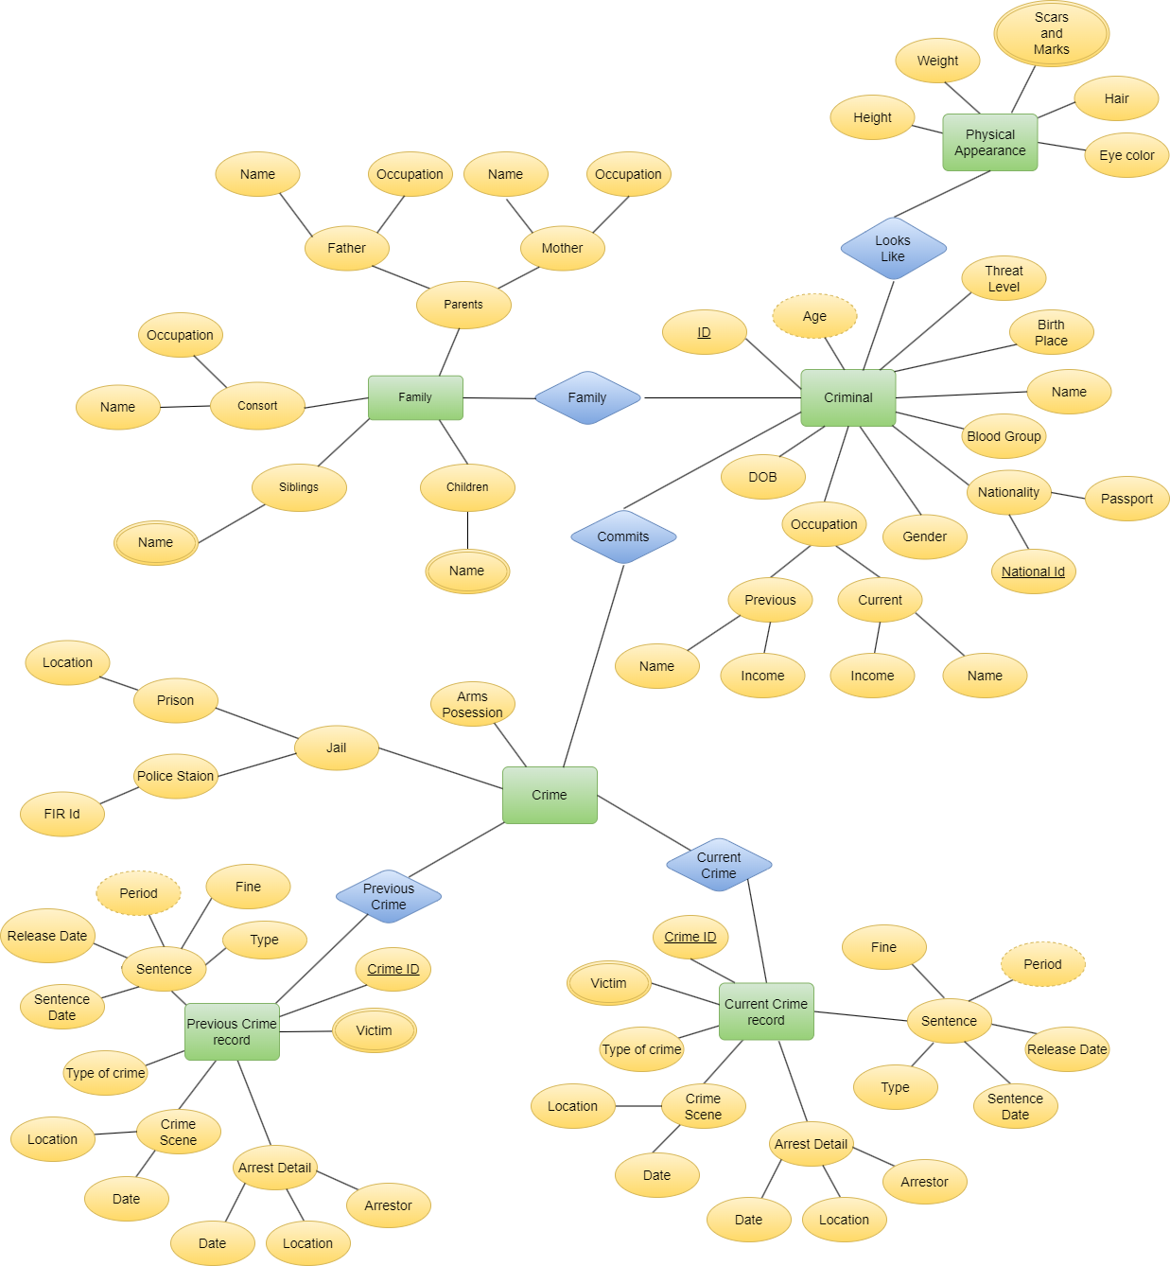

# Relational DB Mapping:

1. Criminal (criminal_id, name, birth_place, dob, gender, blood_group, national_id, passport_id, threat_level, previous_occupation_name, previous_occupation_income, current_occupation_name, current_occupation_income)
2. Physical Appearances (criminal_id, height, weight, eye_color, hair, scars_and_marks)
3. Scars and Marks Relation (criminal_id, scars_and_marks)
4. Family (criminal_id, mother_name, mother_occupation, father_name, father_occupation, consort_name, consort_occupation, siblings_name, children_name)
5. Siblings Relation (criminal_id, siblings_name)
6. Children Relation (criminal_id, children_name)
7. Current Crime (crime_id, type_of_crime, date, crime_scene_location, crime_scene_date, arrest_location, arrest_date, arrestor, sentence_type, sentence_date, sentence_period, release_date, fine)
8. Current Victims (crime_id, victims)
9. Previous Crime (crime_id, type_of_crime, date, crime_scene_location, crime_scene_date, arrest_location, arrest_date, arrestor, sentence_type, sentence_date, sentence_period, release_date, fine)
10. Previous Victims(crime_id, victims)
11. Crime (criminal_id, arms_possession**,**  prison_location, fir_id)